create a dockerfile , docker-compose file which when executed must display your basic details in the website

Step 1:

Create or search java application file .

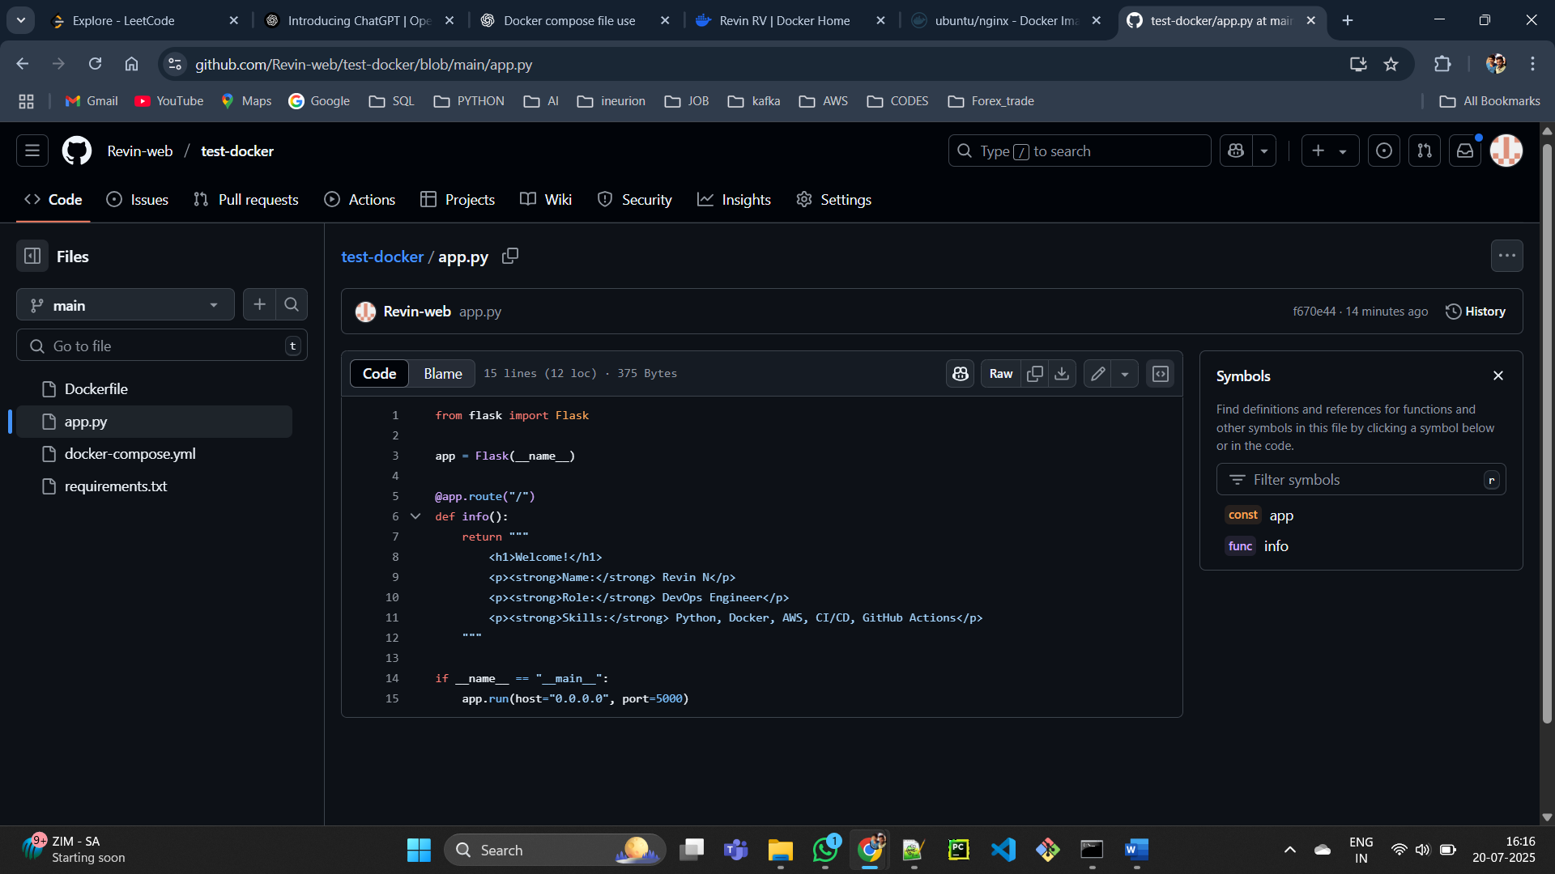

Step 2: Text file.

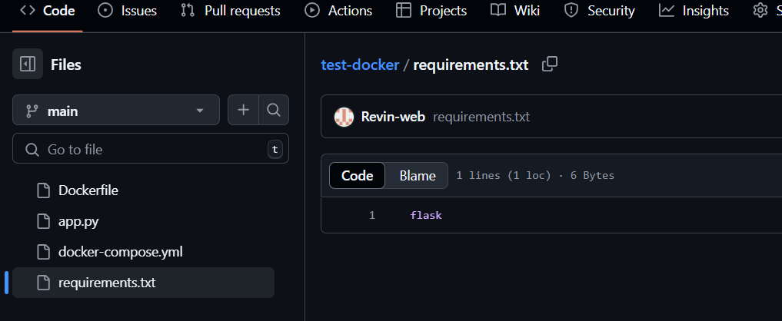

Step 3:

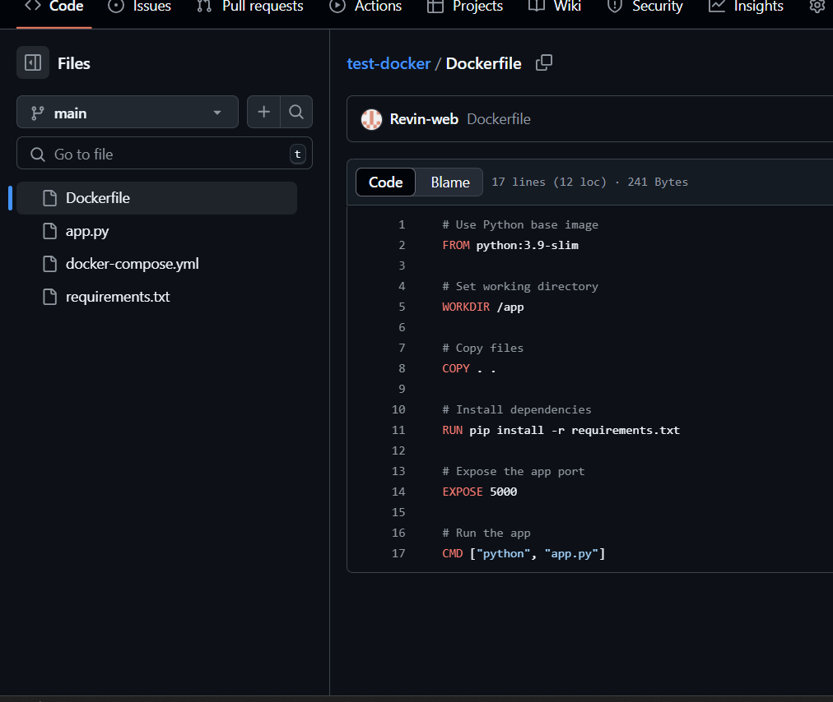

Docker compose file :

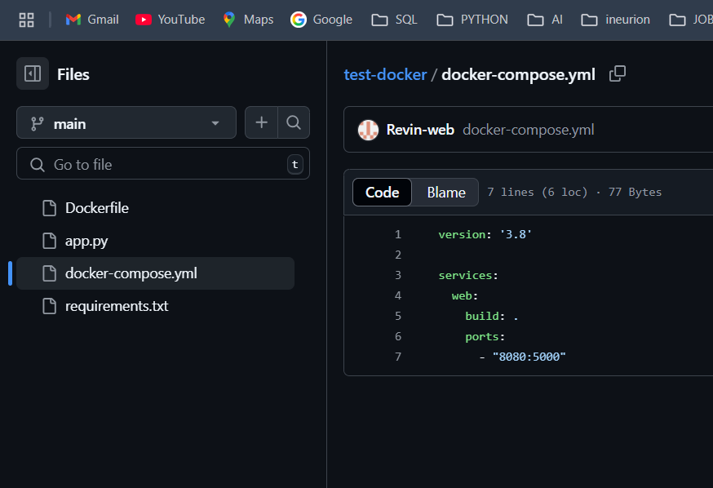

Step 5: create EC2 instance

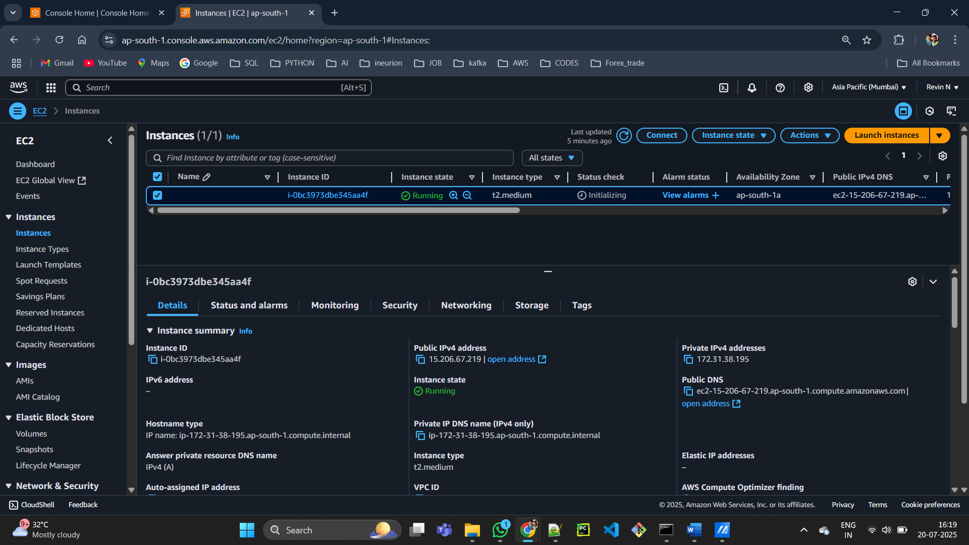

Step 6 : Install DOCKER and Docker compose

sudo apt-get update

sudo apt-get install ca-certificates curl

sudo install -m 0755 -d /etc/apt/keyrings

sudo curl -fsSL https://download.docker.com/linux/ubuntu/gpg -o /etc/apt/keyrings/docker.asc

sudo chmod a+r /etc/apt/keyrings/docker.asc

# Add the repository to Apt sources:

echo \

"deb [arch=$(dpkg --print-architecture) signed-by=/etc/apt/keyrings/docker.asc] https://download.docker.com/linux/ubuntu \

$(. /etc/os-release && echo "${UBUNTU_CODENAME:-$VERSION_CODENAME}") stable" | \

sudo tee /etc/apt/sources.list.d/docker.list > /dev/null

sudo apt-get update

sudo apt-get install docker-ce docker-ce-cli containerd.io docker-buildx-plugin docker-compose-plugin

**step 7: edit inbound rule to access port your are using i.e (8080)**

step 8 : get access to the gitcommit

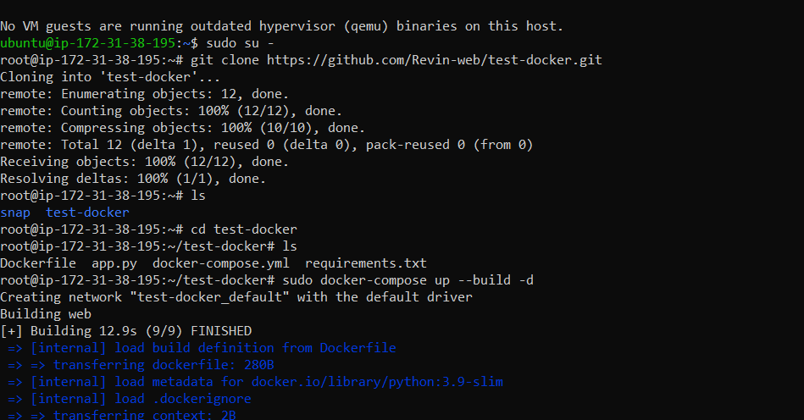

Step 9 : launch the app using ip address with port

